Predicting best location for a restaurant in Toronto

Deborima Das Biswas

April 2019

1. Introduction
   1. Background

ABC group wants to start a restaurant in the City of Toronto. They want to analyze the type of restaurants in the different areas of the city and to predict the best location for opening an Indian restaurant. Location plays an important role in opening a restaurant. They are interested to know which locality has minimum number of Indian restaurants so that their restaurant can attract more number of people.

* 1. Problem

The city of Toronto has a number of restaurants. And the success of the restaurant depends a lot on its location. It is best to open the restaurant in a location where there is minimum number of Indian restaurants. The aim o this project is to determine a possible location for the new restaurant.

* 1. Interest

ABC group be interested to find the location in Toronto which has less number of Indian restaurants. Other organizations who are into specialised restaurant may also be interested.

1. Data acquisition and cleaning

2.1 Data sources

I scraped the Wikipedia page <https://en.wikipedia.org/wiki/List_of_postal_codes_of_Canada:_M> for the neighbourhoods of the Toronto City. This data, however doesn’t have Geopatial data so to fetch the Geopatial data, I used the file located at <https://cocl.us/Geospatial_data>.

I fetched the details of the Indian restaurants from Foursquare API.

2.2 Data cleaning

The data obtained from the two sources were cleaned and combined into one dataset.

There were a few issues with the data scraped from Wikipedia , First there were some Boroughs which were marked as ‘Not Assigned’ which I dropped.

Second, there were few entries with multiple Neighbourhoods having same Boroughs and Postal Code, which I combined into one row.

After cleaning the data, I combined it with the Geospatial data to get the longitude and latitude of the Boroughs.

I then fetched the details of the Indian restaurants using Foursquare API and then analyzed the data to suggest the possible best location for an Indian restaurant.

1. Methodology

I scraped the data for the Toronto City from <https://en.wikipedia.org/wiki/List_of_postal_codes_of_Canada:_M> .

Using Foursquare API, I fetched the restaurants which specialises in Indian cuisine in Toronto.

I sorted the data to find the Borough and Neighbourhood which has minimum number of Indian restaurants. I used Bar Plot (matplotlib.pyplot) to find this data.

Then I fetched the details like Rating, tips etc for these Indian restaurants from Foursquare API.

Using the Rating, I sorted the data to find the Boroughs and Neighbourhoods which has lowest number of Indian restaurants with Top average Rating.

1. Results:

I found that there are three Boroughs which have the minimum number of Indian restaurants. These are Mississauga, Queen's Park and York.

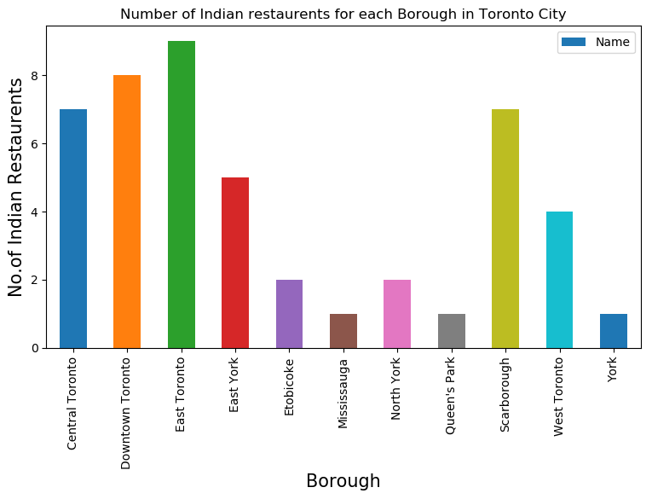

I also analyzed which neighbourhood has the minimum number of Indian restaurants using the bar plot and found that there are 20 Neighbourhoods which has only ONE Indian restaurants.

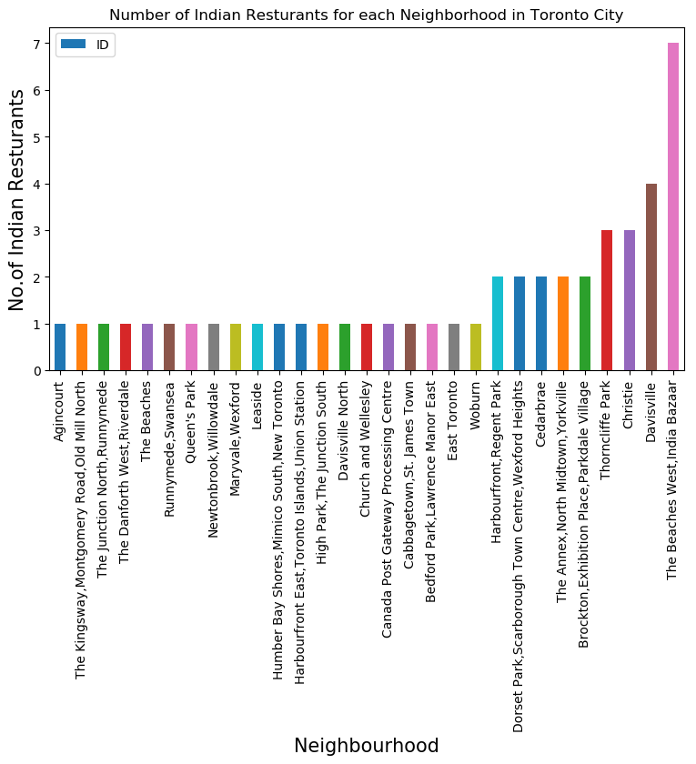

I fetched the Ratings of the Indian restaurants from Foursquare API and analyzed the Neighbourhoods having minimum number of Indian restaurant with Top Rating for these restaurants.

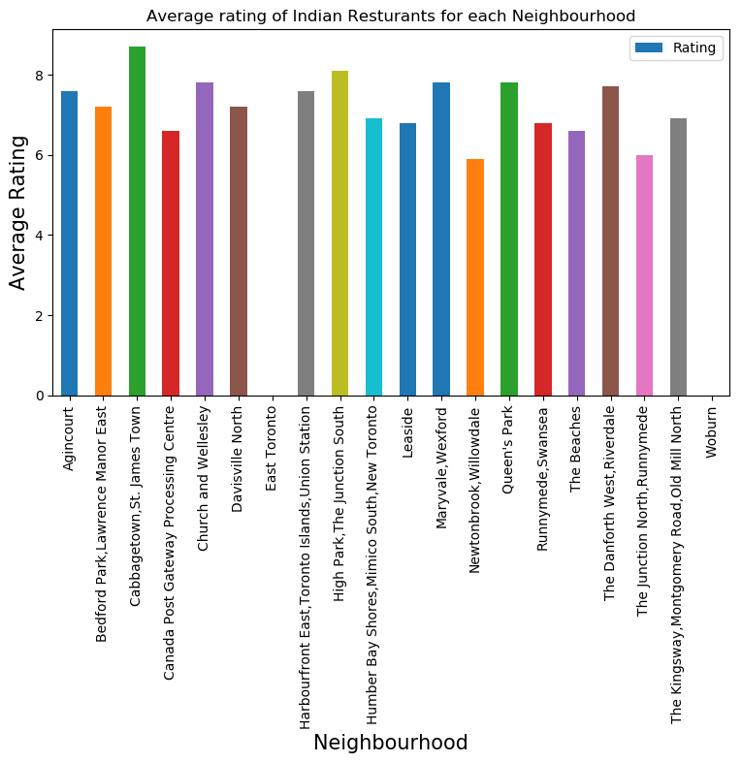

From above plot we see that the Neighbourhood 'Cabbagetown, St. James Town' has the Top Average rating among the Neighbourhoods having minimum number of Indian restaurants.

1. Conclusion:

From above analysis we can conclude that Boroughs Mississauga, Queen's Park and York are good places to look for opening Indian restaurants since there are not too many restaurants in these boroughs.

Also the Neighbourhood 'Cabbagetown, St. James Town' has the Top rating for Indian restaurant among the Neighbourhoods having minimum number of Indian restaurants. So this neighbourhood could be a potential competitor if our client opens restaurant in this location. Also this neighbourhood can be a choice for Indian migrants staying around this area since there are not many restaurants in this locality.

s